1. Configure Classic Load balancer.

**Create a Load Balancer**

* Navigate to **Load Balancers** under **EC2**.
* Click **Create Load Balancer**.
* Choose **Classic Load Balancer**.
* Click **Continue**.

Create 2 public instances with different regions subnet

Write the script to download httpd in both ec2 and create index.html files

Broswe:

classic-loadbalancer-1027120348.us-east-1.elb.amazonaws.com

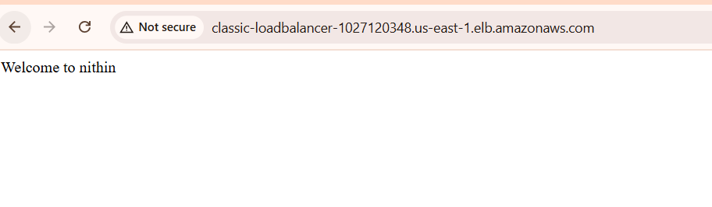

1. Configure Application Load balancer.

**Step 1: Prepare EC2 Instances**

Make sure you have:

* At least **2 EC2 instances** running in **2 different Availability Zones**.
* Apache or Nginx installed (serving a web page).
* **Security group** allowing:
  + **Inbound HTTP (port 80)**
  + **Outbound internet access**

**✅ Step 2: Create a Target Group**

Go to **EC2 Dashboard > Target Groups**.

Click **Create target group**.

Select:

* + **Target type**: Instances
  + **Protocol**: HTTP
  + **Port**: 80

Give it a name (e.g., my-target-group).

Choose **VPC**.

**Health check path**: /

Click **Next**.

Select the EC2 instances to include.

Click **Include as pending below**, then **Create target group**.

**Step 3: Create the Application Load Balancer**

Go to **EC2 Dashboard > Load Balancers**.

Click **Create Load Balancer** → Choose **Application Load Balancer**.

Set the following:

* + **Name**: my-alb
  + **Scheme**: Internet-facing
  + **IP type**: IPv4
  + **Listeners**: HTTP (port 80)

**Availability Zones**:

* + Select at least 2 AZs
  + Select the appropriate **subnets**

Click **Next: Configure Security Settings** → Skip this (HTTP only).

Click **Next: Configure Security Groups**:

* + Use an existing group or create one that allows **HTTP (port 80) inbound**.

Click **Next: Configure Routing**:

* + Choose the **target group** you created earlier.
  + Click **Next** → **Create Load Balancer**

**tep 4: Test the ALB**

1. Go to **Load Balancers** → Select your ALB.
2. Copy the **DNS name** of the ALB
3. Open your browser and go to:

http://application-loadbalancer-711334277.us-east-1.elb.amazonaws.com/

1. Configure Network Load balancer.

**Step 1: Prepare EC2 Instances**

Make sure you have **2 or more EC2 instances** running in **different Availability Zones**, with a service listening on a **TCP port** (commonly port 80 or 8080).

**Step 2: Create a Target Group**

1. Go to **EC2 Dashboard > Target Groups**.
2. Click **Create target group**.
3. Select:
   * **Target type**: Instances
   * **Protocol**: TCP
   * **Port**: 80 (or the port your app uses)
   * **Target group name**: e.g., nlb-target-group
4. Choose your **VPC**.
5. Leave **health check** protocol as TCP.
6. Click **Next**.
7. Select your EC2 instances.
8. Click **Include as pending** → then **Create target group**.

**Step 3: Create the Network Load Balancer**

1. Go to **EC2 Dashboard > Load Balancers**.
2. Click **Create Load Balancer** → Choose **Network Load Balancer**.
3. Fill in the following:
   * **Name**: my-nlb
   * **Scheme**: Internet-facing (for public access)
   * **IP address type**: IPv4
4. **Listeners**:
   * Protocol: TCP
   * Port: 80 (or your app’s port)
   * Forward to: your target group (created above)
5. **Availability Zones**:
   * Select at least 2 AZs and their subnets.
6. Click **Create Load Balancer**

**Step 4: Test Your NLB**

1. Go to **Load Balancers** → find your NLB.
2. Copy its **DNS name**

4) Attach SSL for application load balancer.

5) Map Applciation load balancer to R53.

6) Push the application load balancer logs to s3.